


LDC STRATEGIC RESET
A NEW DIRECTION

Background and context
The Land Development Corporation (LDC) is
the Northern Territory Government’s strategic land developer, established under the Land Development Corporation Act 2003 to support economic development, population growth and the delivery of serviced land across the Territory.

Operating as a Government Business Division, LDC is required to act on a commercial basis while aligning with Government priorities. Its role has been to ensure that land is made available in the right locations, at the right time, particularly in circumstances where market conditions or strategic considerations limit private sector delivery.

Over time, LDC has contributed to the development of key industrial precincts and residential communities, supporting major industries, enabling investment, and facilitating population growth across the Territory.

However, since LDC’s inception the development landscape has evolved significantly. Increased private sector capability, changing industry demand, and heightened need for regional housing and infrastructure have highlighted the importance of refining LDC’s role.

LDC’s Strategic Reset - A New Direction

History of LDC

Since its establishment in 2003, LDC has played a central role in the Territory’s development by:
 delivering strategic industrial estates, including major logistics and supply chain hubs
 supporting residential development in response to housing shortages

 facilitating master-planned communities through both partnerships and direct delivery
managing strategic land assets to enable long-term economic growth.

In 2009, legislative amendments expanded LDC’s functions to include partnerships and residential construction, enabling more flexible delivery models. Projects such as Kilgariff Estate demonstrate LDC’s role in responding to regional market gaps, while industrial precincts at East Arm have become key facilitators of economic activity.

Through this work, LDC has balanced commercial operations with delivering public value, contributing to both economic development and community outcomes.

2
LDC’s Strategic Reset – A New Direction

Strategic reset
During 2025, the Northern Territory Government initiated a strategic review of LDC to ensure it remains fit-for-purpose in a changing environment.

The review and reset responds to several key drivers:
a more mature private development market in some locations
a reduced need for direct government ownership of non-strategic industrial assets persistent housing shortages in regional centres
the need for greater clarity on when government intervenes in the market.
The reset aims to:
clearly define LDC’s strategic role
focus activity where it delivers the greatest value for the Territory align operations more closely with Government priorities
strengthen transparency and confidence for industry and the community.
This reset represents an evolution, rather than a departure, from LDC’s core purpose as a commercially focused development agency supporting sustainable, long-term growth across the Northern Territory.
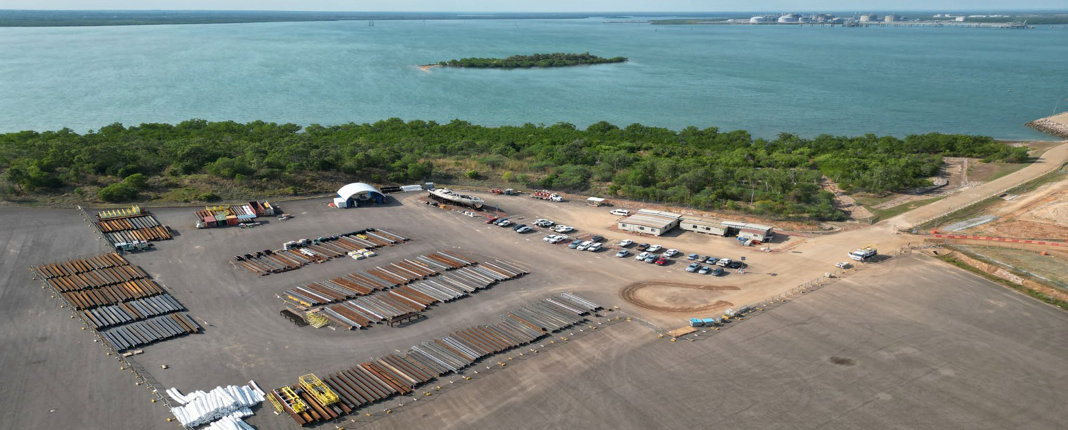



New direction
Following the reset, LDC will adopt a more targeted and strategic role, guided by a clear vision and purpose:

Vision: Deliver strategic land outcomes for industry and Territorians while acting commercially
Purpose: Facilitate the delivery and management of strategic land and estates aligned with Government priorities.

LDC’s future direction focuses on areas where it can deliver the greatest impact: enabling industry growth through strategic precinct development
supporting emerging and priority sectors through land supply
(where there is a strategic requirement or market failure) facilitating infrastructure that underpins economic activity addressing regional housing and development challenges.

This approach ensures LDC complements, rather than competes with, the private sector.

Additionally, based on strong feedback, LDC’s role in the Darwin market will change. This market has matured over time and can be catered for through private developments.

Re-aligned activities and priorities
LDC’s activities will be re-aligned to reflect its reset strategic focus and deliver outcomes in priority areas.

Core strategic priorities

Strategic development precincts | Facilitating industry activity and growth for long-term investment.
Strategic industrial land | Facilitating land supply for priority and emerging industries (particularly when coordi-nated planning or strategic infrastructure is required).
Common user infrastructure | Managing Government-owned strategic and common user key infrastructure in an accessible and commercial manner.
Regional development | Supporting housing and land delivery in regional centres.
Key shifts in activity

Stronger regional focus | Increased focus on residential development in regions experiencing housing shortages.
Partnership-based delivery | Greater use of partnerships with industry to deliver master-planned communities (where there is a need for LDC involvement or Government coordination).
Targeted intervention | Engagement only where there is strategic need or infrastructure, or market failure.
Portfolio realignment | Divestment of non-strategic industrial assets and reinvestment into priority areas.
These changes ensure LDC’s resources are directed toward activities that deliver the highest value for the Territory and do not seek to compete with existing private sector delivery.

Areas of LDC activity and future focus
As part of the reset, LDC’s geographic and functional areas of activity will be more clearly defined to ensure its involvement is targeted, transparent and aligned with Territory priorities.

Darwin region – Targeted strategic involvement
The Darwin region has a mature and capable private development market. As a result, LDC’s future involvement in Darwin will be more targeted and focused on areas where there is clear strategic value requiring coordination, infrastructure integration or direct Government oversight.
LDC will primarily operate in the Darwin region where:
development is linked to strategic infrastructure or key economic precincts
coordination across government and industry is required to enable key projects or strategic industries
there is a demonstrated need for Government facilitation or intervention.

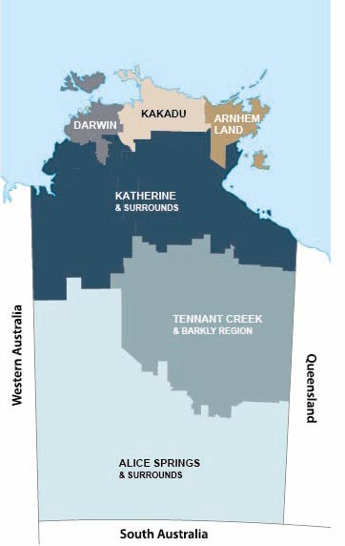
Decisions regarding LDC’s involvement in specific Darwin-based projects or locations will be guided by the decision-making principles and ultimately determined by the Minister. This ensures that Government retains oversight of strategic land use while maintaining LDC’s commercial discipline and responsiveness.

To support transparency and industry confidence, a geographic representation (map) identifies the Darwin regional area contemplated:

Increased focus on regional development
In contrast to Darwin, regional centres across the Northern Territory continue to experience housing shortages, limited private sector activity and constrained development conditions.
LDC will therefore take on a more active role in the regions, with a focus on:

delivering residential land and housing in areas of sustained market failure or supply challenges supporting workforce attraction and retention through increased housing supply
facilitating master-planned developments and enabling infrastructure
partnering with local industry, communities and government to unlock growth opportunities.
This strengthened regional focus recognises that targeted government intervention is critical to enabling economic growth, supporting service delivery and sustaining communities across the Territory.

Portfolio review and realignment
A review of LDC’s portfolio has been undertaken to ensure that its assets and activities align with its renewed strategic role.
Key outcomes of this review include:

divestment of non-strategic industrial assets in the Darwin region, where the private market is well-established and capable of delivering tenancy outcomes independently

stepping back from residential land development in Darwin, reflecting the maturity of the local development market
progressing the divestment of the Fannie Bay (Waratah Crescent) site on commercial terms, enabling private sector redevelopment

reinvesting capital and capability into strategic land, infrastructure and regional priorities.
This realignment ensures that LDC is not competing with the private sector in mature markets, while preserving its ability to intervene where it is most needed.

Consultation and stakeholder input
The reset of LDC has been informed by a Government-led consultation process with industry, community stakeholders and government agencies
Feedback highlighted the importance of:

clearer definition of LDC’s role within the development market greater transparency in decision-making and market intervention stronger focus on regional development and housing
improved alignment with Government priorities and outcomes.

Stakeholder input has been carefully considered and has directly shaped the final reset, including the introduction of a principles-based decision-making framework, portfolio realignment and renewed focus on areas of greatest need.

This approach ensures that LDC’s future direction reflects both Government priorities and the expectations of industry and the community, providing a clear and consistent foundation for delivery moving forward.. LDC’s Executive Leadership Team will continue to build constructive working relationships with stakeholders and align activities with shared Territory outcomes.

Decision making
and the role of the Minister
A key feature of the reset is introducing a clear and transparent decision-making approach around decisions on LDC’s activities.

Role of the Minister
LDC will continue to operate with an independent Chief Executive under the Land Development Corporation Act 2003, maintaining the commercial agility required to deliver land outcomes efficiently.

At the same time, strengthened and increased engagement with the Minister will ensure that LDC’s activities remain aligned with Government priorities with clear oversight. This includes:

- early consultation and consideration of projects and strategic proposals
- regular engagement on LDC activities
- clear accountability and reporting mechanisms.

The Minister is the delegate with the authority to determine LDC’s involvement in strategic projects (or non-involvement as the case may be) and to provide direction where appropriate, ensuring that decisions reflect the broader interests of the Northern Territory while maintaining transparency and confidence in the development process.

Principles
Is the activity strategic for the Territory or related to strategic infrastructure? Would the activity provide an enabling effect to industry or to Territorians?
If the private sector cannot deliver on strategic outcomes or benefits for the Territory, is it beneficial to Government for LDC to be involved?
Would LDC’s involvement be compliant with competitive neutrality principles?

Where these four principles are met, the activity or project may be suitable for further consideration for LDC involvement .

Four core principles
Strategic value
Competitive neutrality
Core principles
Enabling effect
Public benefit
Strategic value
Is the activity strategic for the Territory or aligned with enabling infrastructure?
Enabling effect
Will it unlock development, industry, population or community outcomes?
Public benefit
Is LDC involvement preferable to or distinct from private developer delivery?
Competitive neutrality
Is the activity consistent with competition principles?
If all answers are affirmative, the project would be considered suitable for LDC involvement.

Additional consideration
In addition to the core principles, the Minister may also consider:
whether there is a market failure requiring LDC’s involvement
whether the activity is consistent with LDC’s requirement to operate on a commercial basis (unless otherwise directed by the Minister)
 any broader strategic, policy or reputational implications, including potential perceptions arising from LDC being involved or not involved.
This approach ensures that LDC’s role is clearly defined, targeted and justified in each instance.

Conclusion
The reset of the Land Development Corporation positions it to meet the evolving needs of the Northern Territory.

By sharpening its focus, strengthening governance, and aligning with Government priorities, LDC will continue to play a critical role in enabling economic growth, supporting regional communities, and delivering strategic land outcomes for Territorians.

This renewed approach ensures LDC remains a modern, responsive and commercially focused development agency—working in partnership with industry to build the Territory’s future.

